**Institute of Engineering & Management**

**Department of Computer Science & Engineering**

**Network Lab for 3rd year 6th semester 2019**

**Code: CS 692**

**Date:** 08/04/19

**WEEK-7**

**Assignment-1**

**Problem Statement:** Implement static NAT.

**Screen-Shot:**

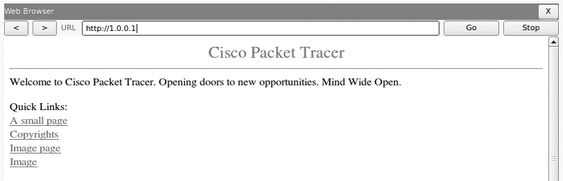

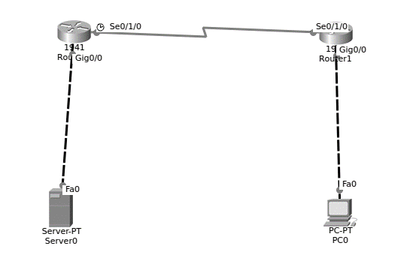

**CLI code:**

**Router-1:**

Router>en

Router#config

Configuring from terminal, memory, or network [terminal]?

Enter configuration commands, one per line. End with CNTL/Z.

Router(config)#interface se0/1/0

Router(config-if)#ip address 10.0.0.1 255.0.0.0

Router(config-if)#clock rate 64000

Router(config-if)#no shutdown

%LINK-5-CHANGED: Interface Serial0/1/0, changed state to down

Router(config-if)#exit

Router(config)#interface gig0/0

Router(config-if)#ip address 192.168.10.1 255.255.255.0

Router(config-if)#exit

Router(config)#

%LINK-5-CHANGED: Interface Serial0/1/0, changed state to up

%LINEPROTO-5-UPDOWN: Line protocol on Interface Serial0/1/0, changed state to up

interface gig0/0

Router(config-if)#no shutdown

Router(config-if)#

%LINK-5-CHANGED: Interface GigabitEthernet0/0, changed state to up

%LINEPROTO-5-UPDOWN: Line protocol on Interface GigabitEthernet0/0, changed state to up

Router(config-if)#exit

Router(config)#ip nat inside source static 192.168.10.2 1.0.0.1

Router(config)#interface gig0/0

Router(config-if)#ip nat inside

Router(config-if)#exit

Router(config)#interface se0/1/0

Router(config-if)#ip nat outside

Router(config-if)#exit

Router(config)#ip route 192.168.11.0 255.255.255.0 10.0.0.0

Router(config)#

**Router-2:**

Router>en

Router#config terminal

Enter configuration commands, one per line. End with CNTL/Z.

Router(config)#interface se0/1/0

Router(config-if)#ip address 10.0.0.2 255.0.0.0

Router(config-if)#exit

Router(config)#interface gig0/9

%Invalid interface type and number

Router(config)#interface gig0/0

Router(config-if)#ip address 192.168.11.1 255.255.255.0

Router(config-if)#no shutdown

Router(config-if)#

%LINK-5-CHANGED: Interface GigabitEthernet0/0, changed state to up

%LINEPROTO-5-UPDOWN: Line protocol on Interface GigabitEthernet0/0, changed state to up

interface se0/1/0

Router(config-if)#no shutdown

Router(config-if)#

%LINK-5-CHANGED: Interface Serial0/1/0, changed state to up

Router(config-if)#

%LINEPROTO-5-UPDOWN: Line protocol on Interface Serial0/1/0, changed state to up

Router(config-if)#ip route 1.0.0.0 255.0.0.0 10.0.0.0

Router(config)#

Router#

%SYS-5-CONFIG_I: Configured from console by console

Router#

**Assignment-2**

**Problem Statement:** Implement PAT.

**Screen-Shot:**

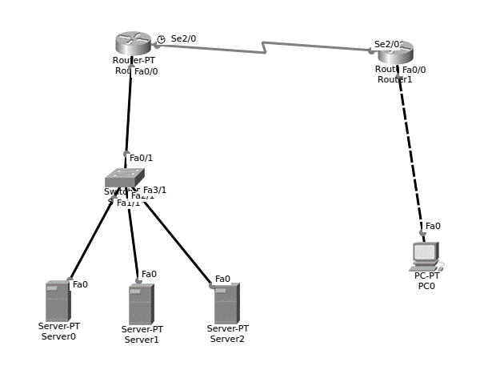

**CLI Code:**

**Router-1:**

Router>en

Router#config termi

Router#config terminal

Enter configuration commands, one per line. End with CNTL/Z.

Router(config)#interface fa0/0

Router(config-if)#ip address 192.168.10.1 255.255.255.0

Router(config-if)#no shut down

Router(config-if)#

%LINK-5-CHANGED: Interface FastEthernet0/0, changed state to up

%LINEPROTO-5-UPDOWN: Line protocol on Interface FastEthernet0/0, changed state to up

Router(config-if)#exit

Router(config)#interface se2/0

Router(config-if)#ip address 10.0.0.1 255.0.0.0

Router(config-if)#clock rate

% Incomplete command.

Router(config-if)#clock rate 64000

Router(config-if)#no shutdown

%LINK-5-CHANGED: Interface Serial2/0, changed state to down

Router(config-if)#exit

Router(config)#

%LINK-5-CHANGED: Interface Serial2/0, changed state to up

%LINEPROTO-5-UPDOWN: Line protocol on Interface Serial2/0, changed state to up

Router(config)#exit

Router#

%SYS-5-CONFIG_I: Configured from console by console

Router#config te

Router#config terminal

Enter configuration commands, one per line. End with CNTL/Z.

Router(config)#ip route 192.168.11.0 255.255.255.0 10.0.0.0

Router(config)#access list 2 permit 192.168.10.0 0.0.0.255

^

% Invalid input detected at '^' marker.

Router(config)#interface se2/0

Router(config-if)#access list 2 permit 192.168.10.0 0.0.0.255

^

% Invalid input detected at '^' marker.

Router(config-if)#exit

Router(config)#access-list 2 permit 192.168.10.0 0.0.0.255

Router(config)#ip nat pool a 1.0.0.1 1.0.0.1 netmask 255.0.0.0

Router(config)#ip nat inside source list 2 pool a overload

Router(config)#interface fa0/0

Router(config-if)#ip nat inside

Router(config-if)#exit

Router(config)#interface se2/0

Router(config-if)#ip nat outside

Router(config-if)#exit

Router(config)#

**Router-2:**

Router>en

Router#config tr

Router#config t

Router#config terminal

Enter configuration commands, one per line. End with CNTL/Z.

Router(config)#interface fa0/0

Router(config-if)#ip address 192.168.11.1 255.255.255.0

Router(config-if)#no shutdown

Router(config-if)#

%LINK-5-CHANGED: Interface FastEthernet0/0, changed state to up

%LINEPROTO-5-UPDOWN: Line protocol on Interface FastEthernet0/0, changed state to up

Router(config-if)#exit

Router(config)#interface se2/0

Router(config-if)#ip address 10.0.0.2 255.0.0.0

Router(config-if)#no shutdown

Router(config-if)#

%LINK-5-CHANGED: Interface Serial2/0, changed state to up

%LINEPROTO-5-UPDOWN: Line protocol on Interface Serial2/0, changed state to up

Router(config-if)#exit

Router(config)#ip route 192.168.10.0 255.255.255.0 10.0.0.0

Router(config)#